Bikes of Battle Mountain 2013
 | Vehicle/Info | Rider(s) | Designer/Builder | Country | Class | Notes | Max Speed
 | VeloX S1 | Jan Bos | David Wielemaker,  Hans van Vugt | Netherlands | men's bike | front window | 74.13
 | VeloX S2 | Ellen Van Vugt | David Wielemaker,  Hans van Vugt | Netherlands | women's bike | front window | 68.28
 | VeloX 3 | Sebastiaan Bowier | Human Power Team Delft | Netherlands | men's bike | camera | 83.13
 | VeloX 3 | Wil Baselmans | Human Power Team Delft | Netherlands | men's bike | camera | 79.18
 | Nitro | Ben Goodall | Ben Goodall / Trisled | Australia | men's bike | head pod | 71.85
 | Primal 2 | Blake Anton | George Leone / Team Primal | USA | men's bike | front window | 61.85
 | Svengali | Sven Jorgensen | Sven Jorgensen | USA | men's bike | head pod | 50.52
 | Bowstring/Tetiva-3 | Sergey Dashevsky | Veniamin Ulyanovskiy | Russia | men's bike | front window | 62.4
 | Cygnus - Beta | Jan-Marcel van Dijken | Team Cygnus | Netherlands | men's bike | camera | 78.23
 | Cygnus - Beta | Thomas van Schaik | Team Cygnus | Netherlands | men's bike | camera | 70.43
 | Cygnus - Beta | David Verbroekken | Team Cygnus | Netherlands | men's bike | periscope | 49.26
 | Big Nose Pete | Dave Sianez | Dave Sianez | USA | men's multi-track | front window | 46.75
 | Norus | Mike Mowett | Poirier, Wood, Smith | USA | men's bike | head pod | 59.18
 | Norus | Florian Kowalik | Poirier, Wood, Smith | USA | junior bike | head pod | 55.12
 | Beastie | Graeme Obree | Graeme Obree | Scotland | men's bike | prone/front-window | 56.62
 | Glowworm | Phil Plath, Randy Gillett | Larry Lem | USA | men's multirider | front window | 73.03
 | Tusmobil Eivie | Damjan Zabovnik | Damjan Zabovnik | Slovenia | men's bike | reverse, mirror | 44.74
 | Altair 4 | Aurelien Bonneteau | IUT of Annecy | France | men's bike | Head pod | 77.62
 | Vortex | Alex Selwa | U of Toronto | Canada | men's bike | head pod | 65.69
 | Vortex | Calvin Moes |  |  |  |  | 62.74
 | Vortex | Cameron Robertson |  |  |  |  | 65.49
 |  |  |  |  |  |  | 43.66
 | Vortex | Graeme Obree
 | Vortex | Marc Jutras |  |  |  |  | 68.26
 | Vortex | Oleksiy Ryndin |  |  |  |  | 30.95
 | Bluenose | Calvin Moes | U of Toronto | Canada | men's bike | Camera | 76.5
 | Bluenose | Cameron Robertson |  |  |  |  | 70.72
 | Bluenose | Todd Reichert |  |  |  |  | 77.69
 | Bluenose | Trefor Evans
 |  |  |  |  |  |  | 76.84
 | Varna Tempest | Barbara Buatois | George Georgiev | Canada | women's bike | head pod | 72.28

There were quite a few interesting bikes and tech aspects to Battle Mountain this year.
Firstly there was the question of tyres. Many of the fast bikes were running 406 Michelins in 2 types, the Supermilage Radial Ply (SM) and Solar Vehicle Cross Ply (SV). 2 very different tyres. The Mileage Marathon is quite a solid tyre, with a near flat tread area. Hans Van Vugt says it has half the rolling resistance of an Ultremo. Hard to believe, but that is what VeloX3 used to set a new record. The Velox teams that used it ran tubeless. That means sealing the rim and having some compound to help the tyre seal to the rim. Less hysteresis without tubes. It was very hard to seat them right. To run tubeless you need to put a lot of air in quickly so the tyre seals to the rim. They also seemed to cut quite easily. Jan Bos had this problem and switched to Kojaks. Velox 3 changed tyres for every run. On Monday Ellen had a problem with handling at speed. The tyre pressure had dropped, possibly due to the tubeless fitting. On Tuesday her bike did not feel good between 40 and 60, but went well faster than that.
The Solar Vehicle tyre with blue tyre walls is thin as a condom. Altair used it and did not seem to experience any problems. Bluenose started on SM. The bike didn’t handle well. They changed the front to SV and Todd crashed. After that they used all SV. They tried tubeless but could not get them to seal.
Another theme was safety. We are beginning to realise that travelling over 70mph can be dangerous. The horizontal division the Varnas have is very good for getting in and out fast. Some bikes may need a bit more than Velcro to keep the rider inside. Smaller hatches may be safer.
For me, the machines that stood out as different were Tusmobil Eivie, Altair 4, John Jackson’s incomplete trike, Bluenose and of course The Beastie. Honourable mentions to others will follow.

Tusmobil Eivie

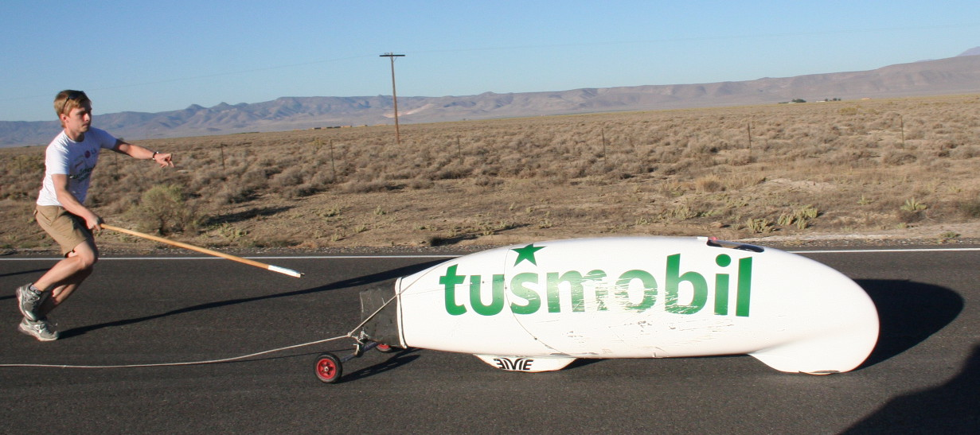

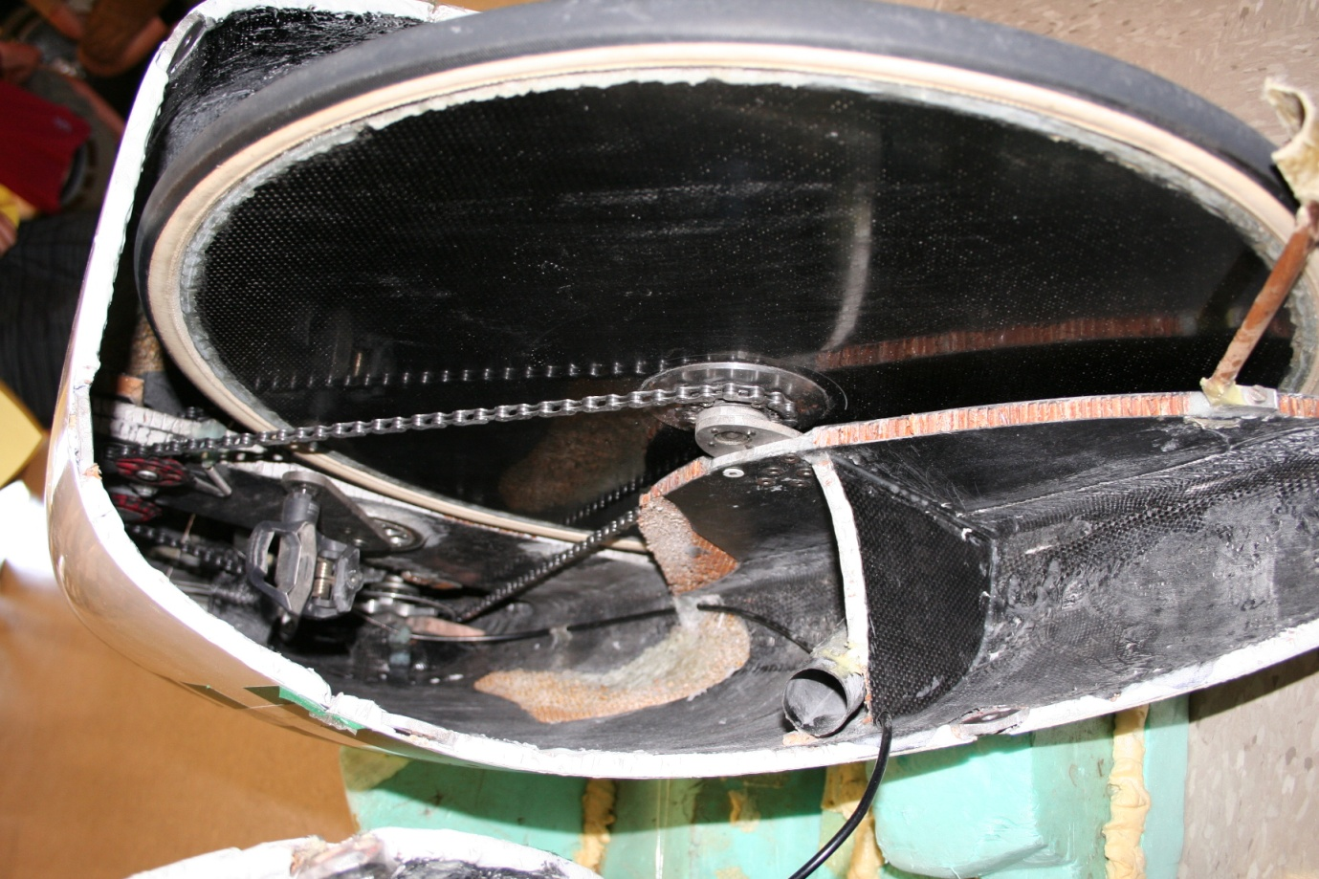
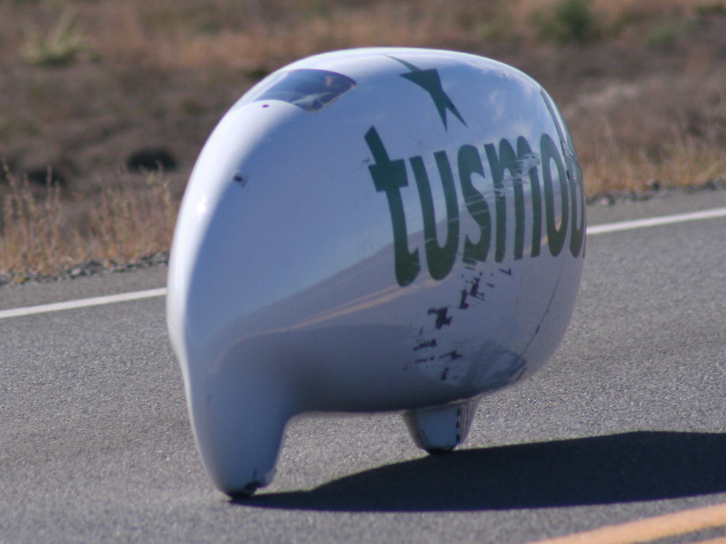
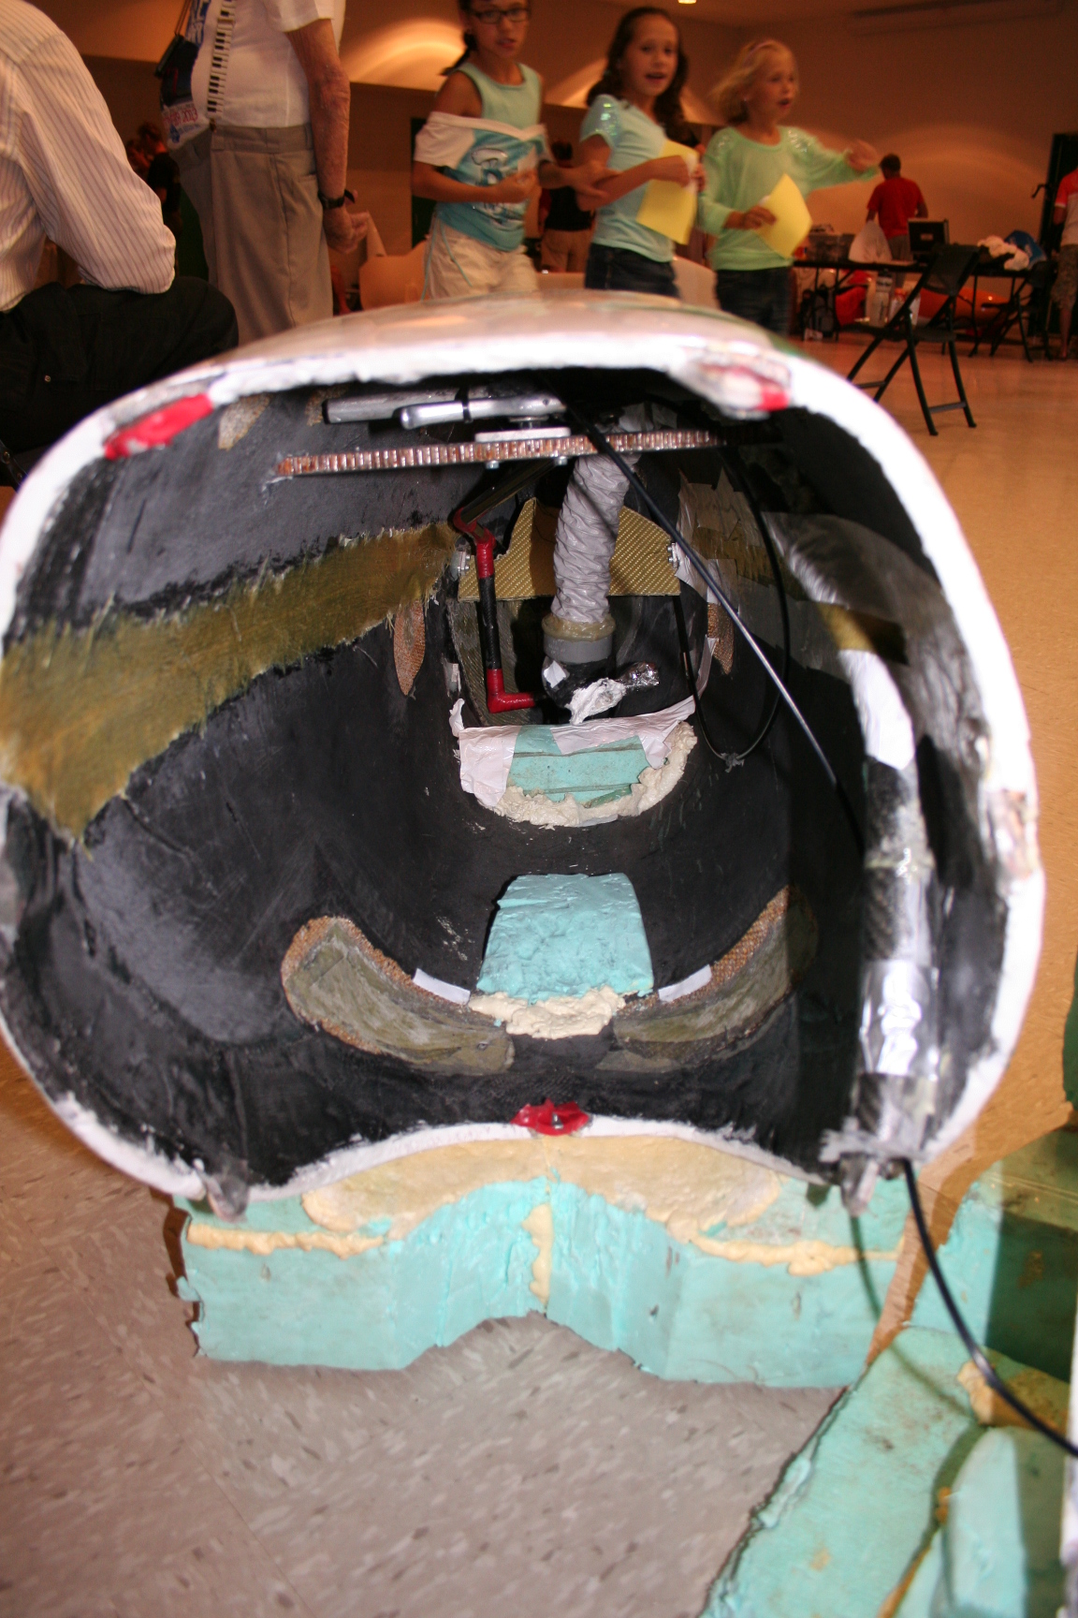
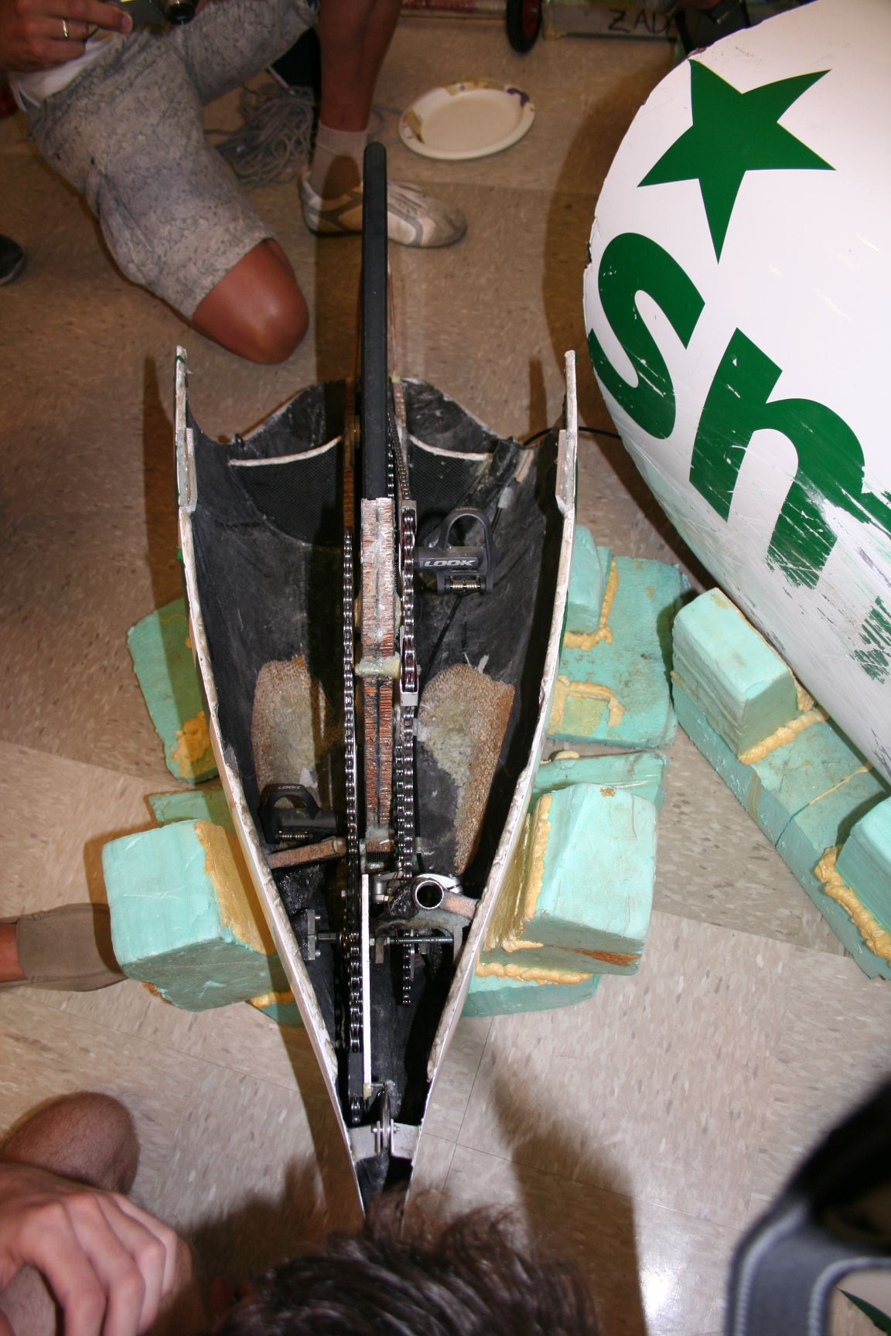
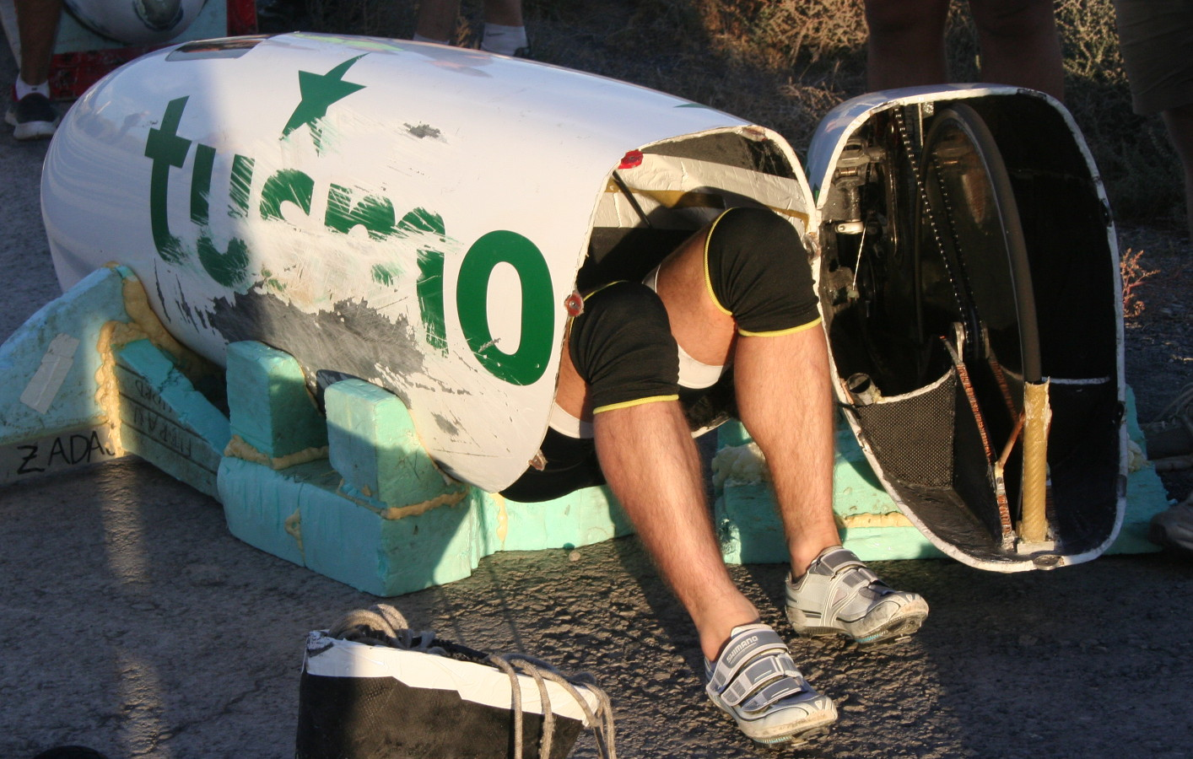
Tusmobil is a sponsor. They are a bathroom fittings company. It literally means Douchemobile! The last Eivie had the crank axle through the back wheel and gears and drive reverse in the tail. The latest has the cranks behind and slightly above the wheel. It still has the drive in the tail, but that has been made much narrower. There is a chain each side of the rear wheel and an exchange shaft. The cogs slide on the shaft to change gear which means the chains do not bend and are as narrow as possible. This isn’t an entirely new idea. Some of the earliest derailleurs had moving cogs. Georgi Georgiev had something similar in the Varna Torso about ’89 and The Mango also had such a drive. The means of chain tension and reversing is best shown in diagrams. Damjan didn’t go well. He uses a launch trolley with foam mat to hold the bike in. It got dusty and would not retain. He added some of the sticky mat intended to hold a mobile phone on a dashboard. Seemed to launch like a train, but didn’t hit high speeds. I will ask him why. The new bike is even smaller than the last and the new crank position allows it to be a bit higher off the ground. The last bike was very low. Safety was different too. On the new bike the shell back to the narrowing point (2/3rds) was one piece. The last part with the drive bolted on with 8 bolts, hinged for entry. The tail part is divided horizontally to allow access to the works. I had a conversation with Damjan about why he didn’t go as fast as we expected.
JW After the launch probs you seemed to be going well, but only hit 44. Can you give me some idea why? I am doing a write-up for the BHPC mag. I can arrange to get you a copy when it comes out.
DZ I had some stability problems and to go faster than 50 mph was very risky. I went 85km/h only once where the slope is the biggest on the course, but almost crashed. I had to pedal in the fifth gear not to provoke harmonic oscillation. The good part is the bike will be fixed and ready and fast in the 2014.
JW Thanks very much. I once made a prone which had the cranks a long way behind the rear wheels. The back end twisted about due to weight movement. Could your cranks be a bit far back?
DZ Yes, you are right. I need to stop tendencies of mass movements to bend parts. If needed I will move rear wheel more to the back.

Altair 4
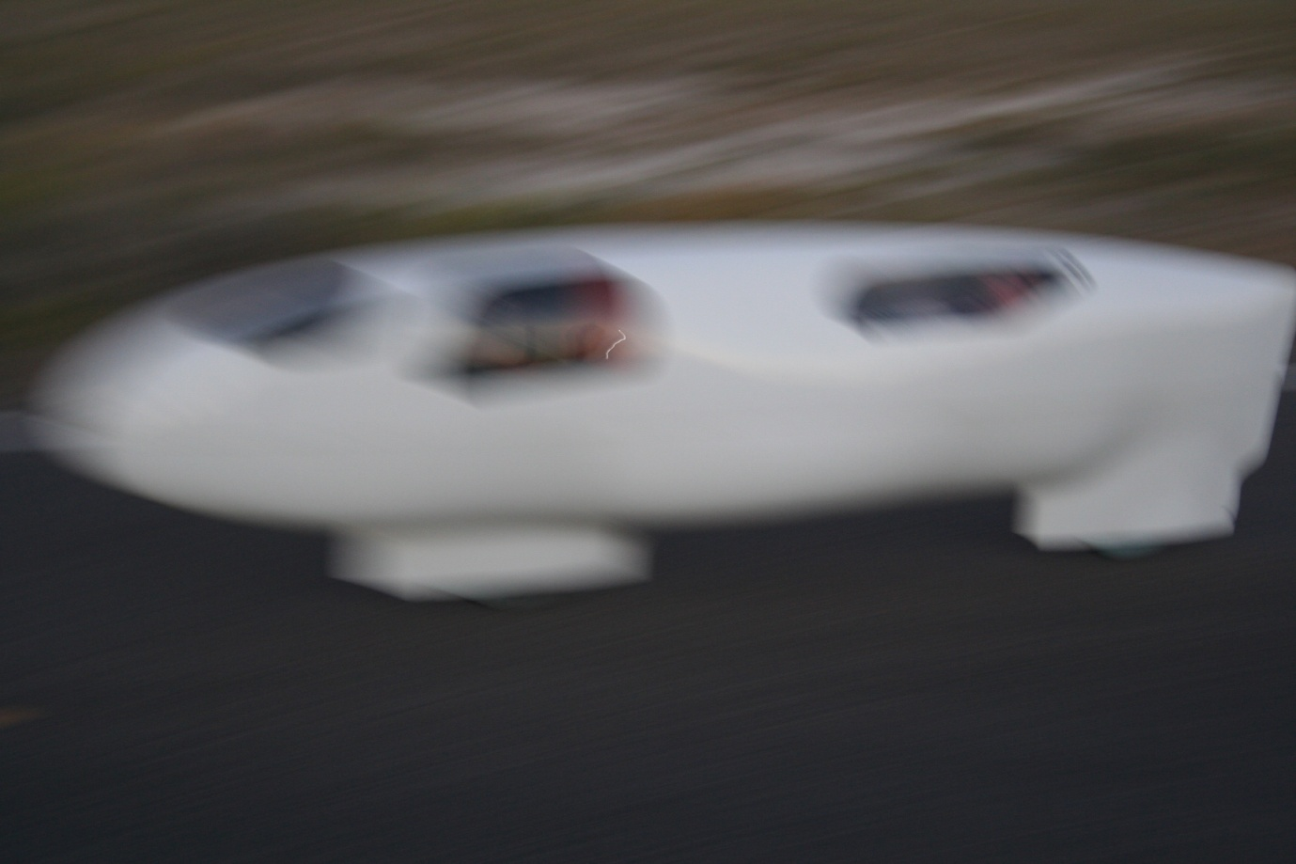
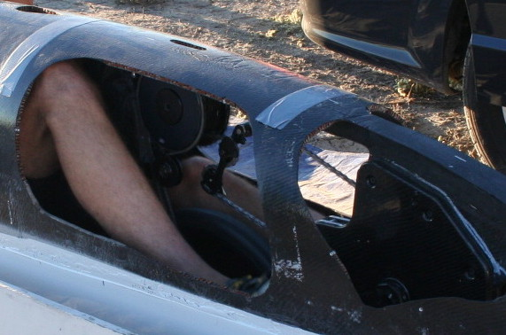
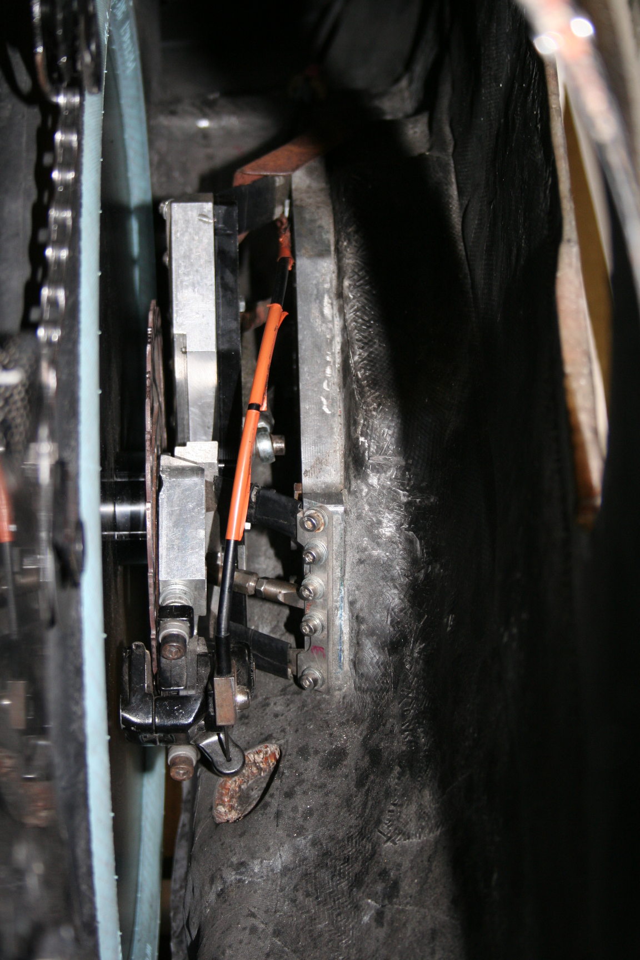
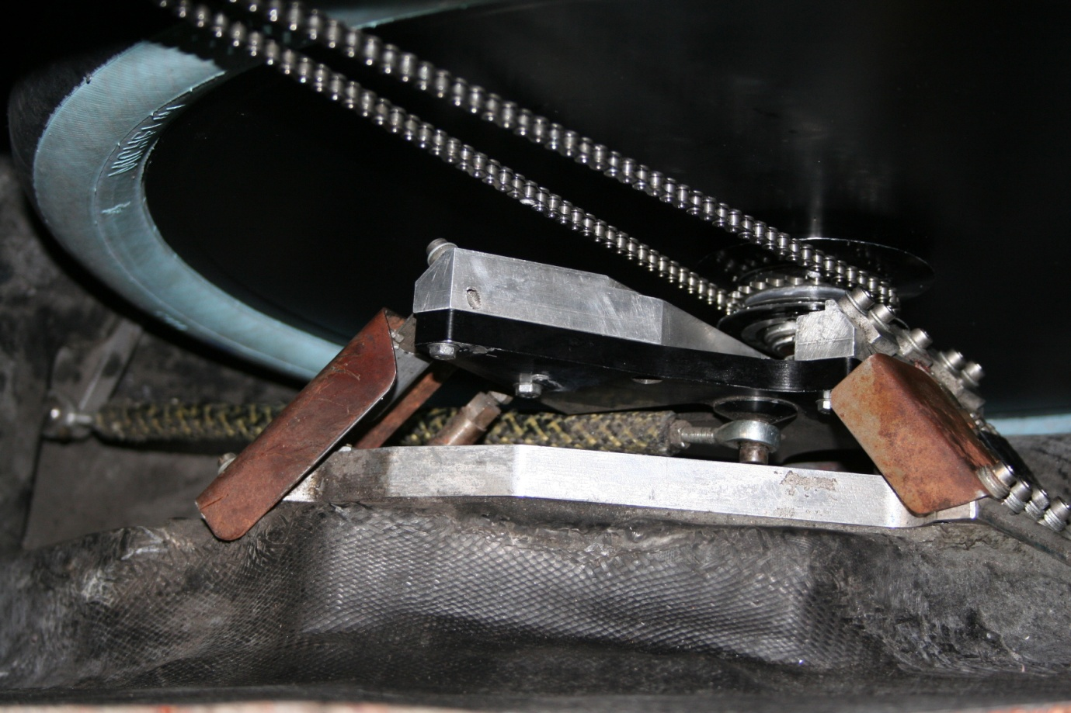
Similar to last year, but worked better. It is a very long, slightly bumpy torpedo, set up on wheel fins. Very small frontal area and a huge engine. The front chainring is between the 2 x 10 mm sheets of Nomex composite which mount the bearings. Q factor is very small. It drives to a conventional set of gears below the upper part of the frame, quite like the Beano. The final drive to the front wheel is short pitch chain. The clever bit is there is no headset. Steering is achieved in a completely different manner. Each side of the front wheel there is a substantial rectangular plate. Those plates are linked to the shell by similar plates, with pivots. Looking down, each side is like a truncated pyramid. Normally the plate on the wheel and the side of the shell are roughly parallel, but the wheel can pivot through a small arc by skewing the quadrilaterals. The plates are actually linked by a number of links, rather than a solid. I can’t figure out the angles required to make it work. Over to you GST? The whole setup is rigid enough to resist chain pull. It provides a good anchor for a disk brake. Steering is remote, with a carbon tube moving the wheel. Altair is also an example of a safety trend. It has a solid structure under the streamlined top, with cut-outs to get in and to access components. Nitro Glycerine is another like this.

John’s trike
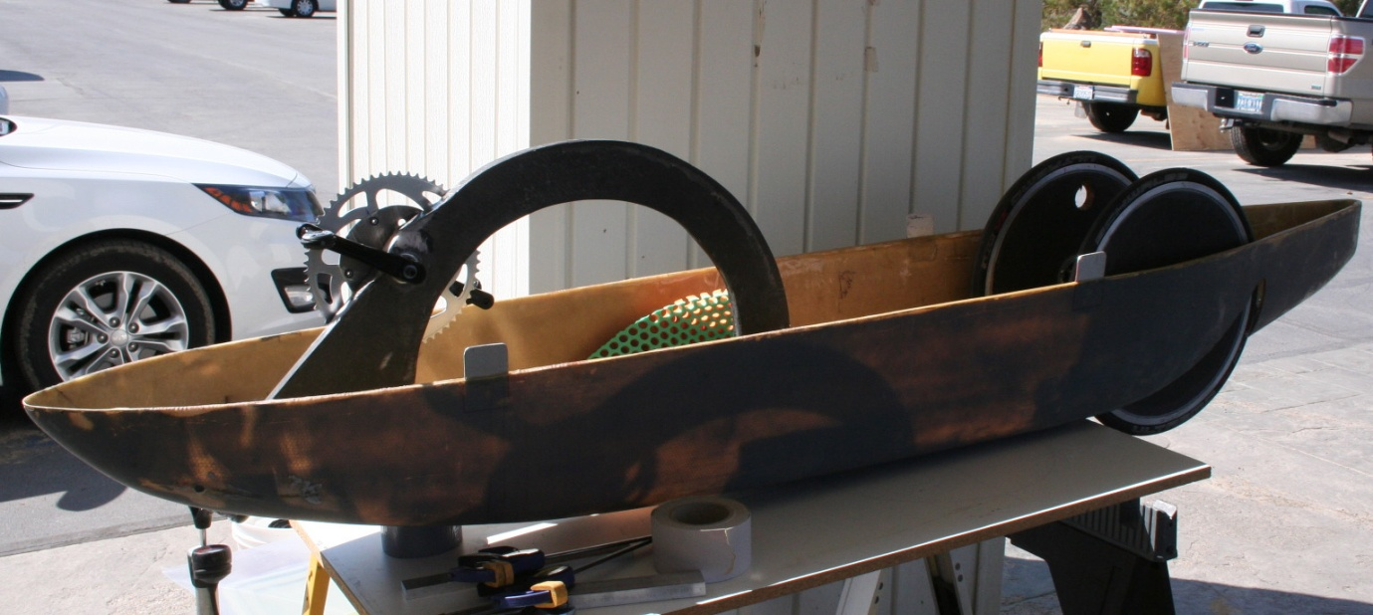
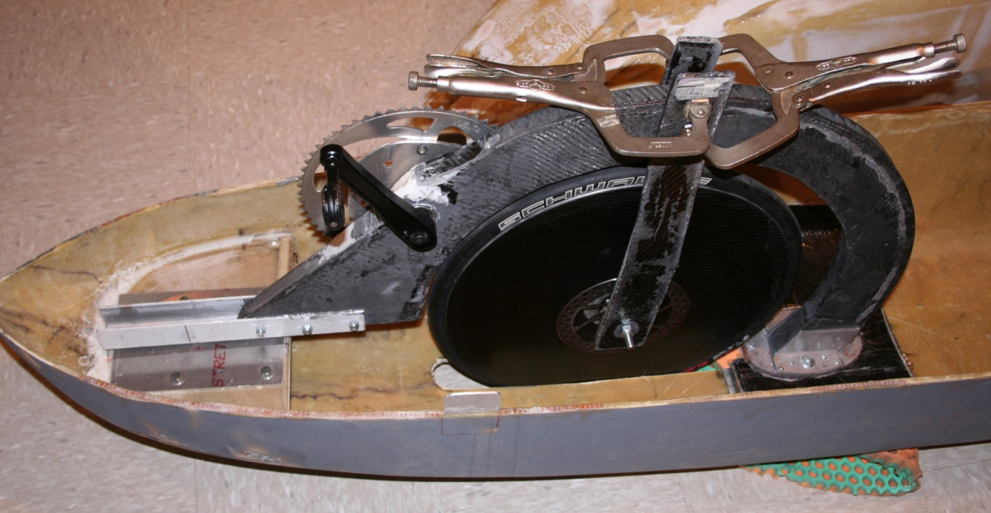
John Jackson has been in process for a couple of years. Straight line trikes like these don’t really need to steer. Trimming is enough. Steering risks shimmy. John has his front wheel and cranks mounted on a subframe. It has a pivot at the back of the front wheel and the front part of the subframe can be moved sideways a bit to trim direction. He currently has a very narrow rear track, too narrow for the multi track class, and the rear axles are too flexible. John plans to remedy this by extending them into the monocoque shell. It still needs a lot of work, but it’s very simple and can easily house gears. It is very small. 2 possible female riders turned up. Cindy from Florida is a petite bike racer. She had a bad head injury and can’t balance 2 wheels, but she’s strong. Teagan is 17 and quite small. Michelle Hammersmark (an old friend of the event) has adopted her. Teagan is cycling mad and has been measured at 300 watts. Ideal pilot!

The Bluenose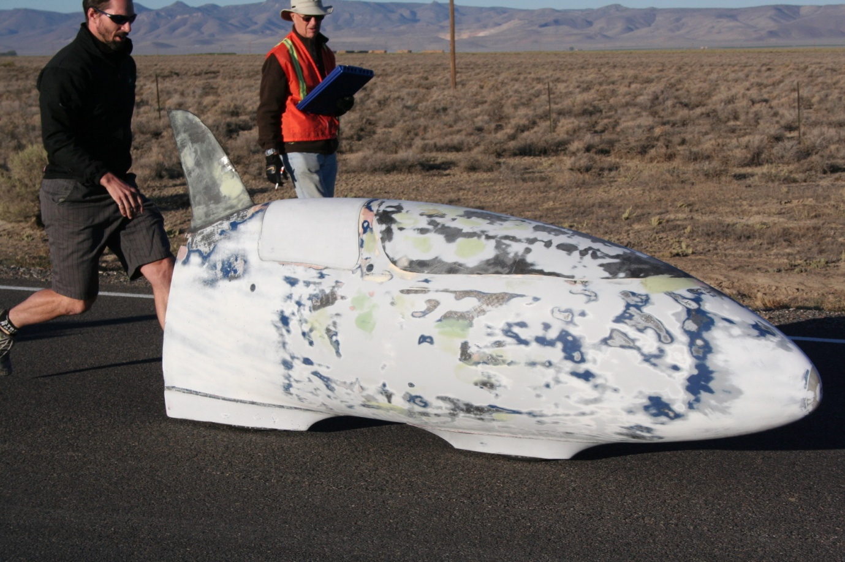
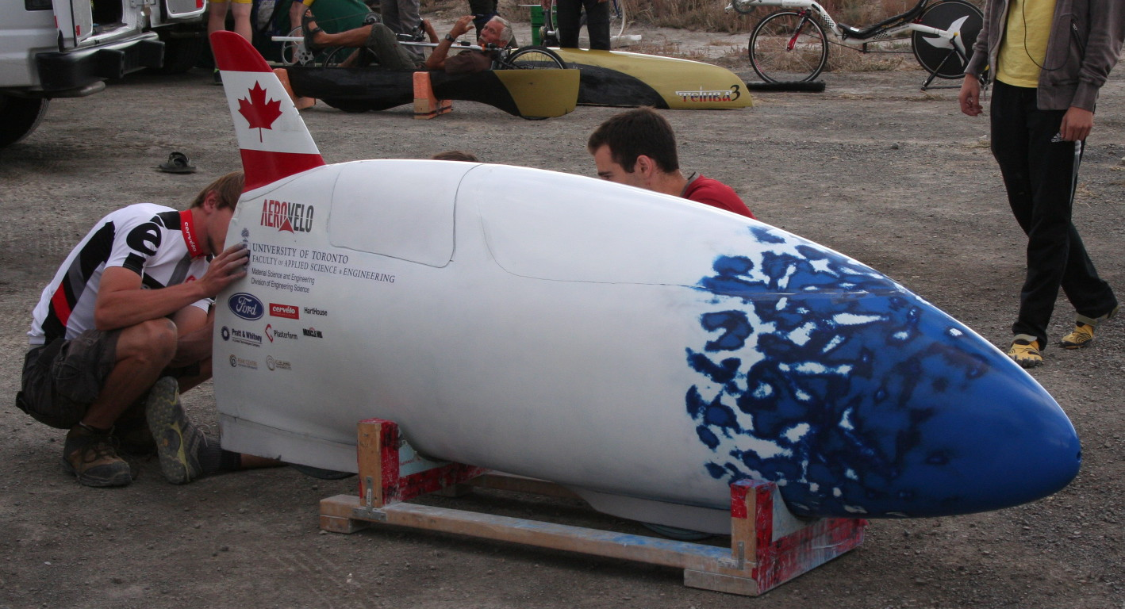 Was around last year. It didn’t cope with side winds. They have re-done all the geometry. It is basically an ASME* circuit racer, so not very long. It looks a bit like a cross between The Beano and The Fish. More curvy than the former, smaller than the latter, with a 3D screen. Last year it had a windscreen. This year, for Battle Mountain, that was replaced by a solid screen with cameras mounted on a rear shark fin, which was optimised to improve handling in side winds. In testing, they tried various sizes. Their displays won an innovation award. They used tablets, programmed to include all the bike data. 2 quite large screens. I acted as chase official when Todd Reichert (The helicopter pilot) rode it to over 77mph. He just kept accelerating all the way. Awesome is much over used.
The Beastie
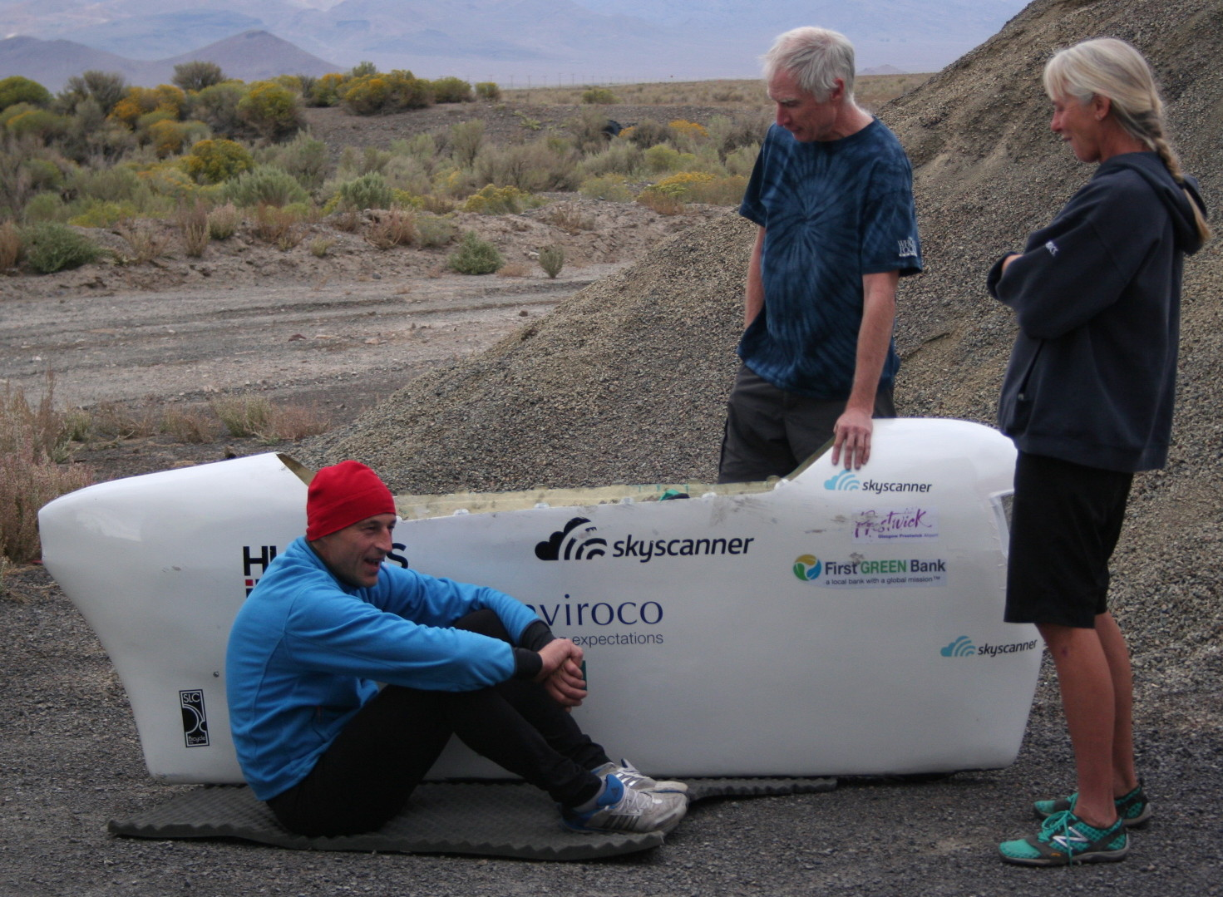
Rather the other end of the scale. A simple steel frame though doubled sideways at the bottom. Fixed single speed and treadle drive. Lots of side area. It was very much to Graeme’s credit he rode it at all. After a couple of start glitches they got starting sorted out. Big Gary the journalist became the launcher. He was tall enough to hold it. Unsophisticated aerodynamics. Graeme said it was uncomfortable. Late in the week he tried Vortex and several unfaired recumbents. Big smiles.
VeloX S1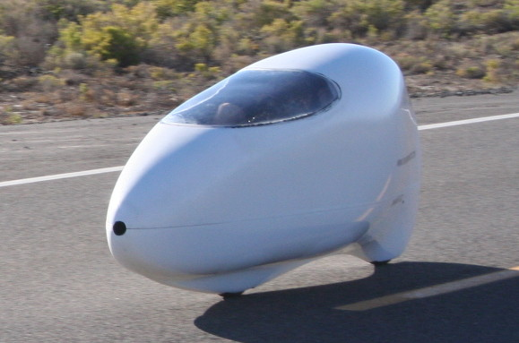
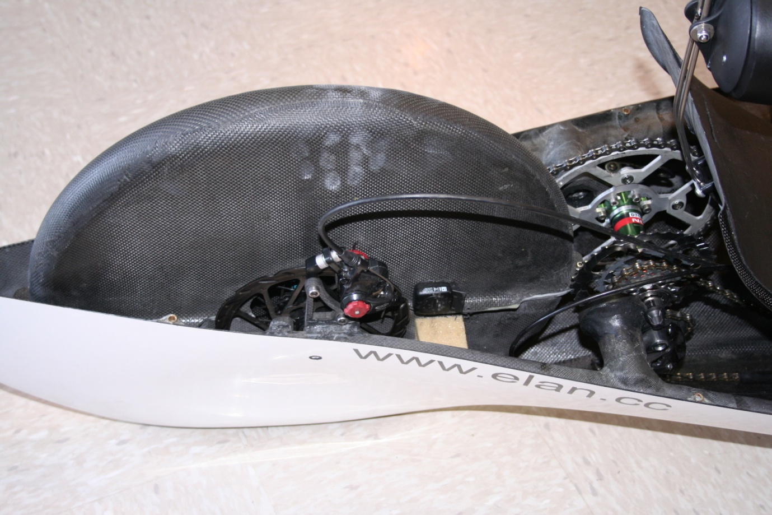
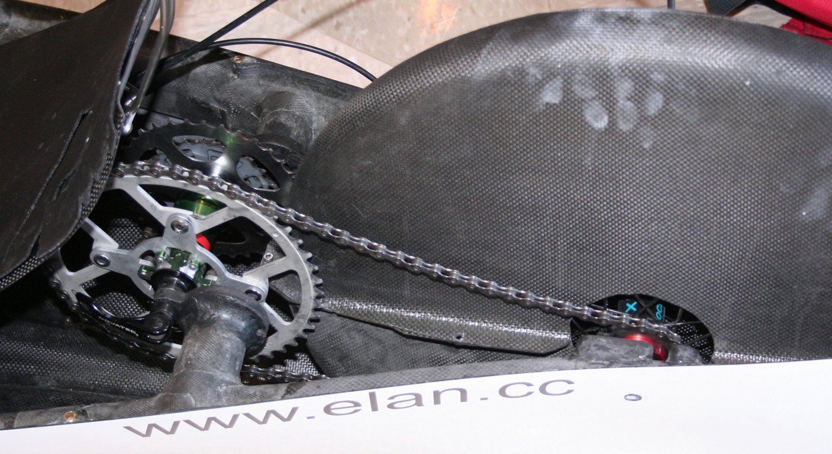 Basically the machine Ellen had last year. It is sliced horizontally. Beautifully built by Hans van Vugt. Shell design by David Wielemaker, who is supposed to have given all this up to finish his degree. It’s addictive. The bike is very neat with full wheel fairings and a transfer shaft in front of the rear wheel. Jan lost the top in a crash, so that may need thinking about. It had tyre problems as above.
VeloX S2 is a new smaller version for Ellen. She had tyre problems as well, but got the SM tyres seated and carried on running them.
Velox 3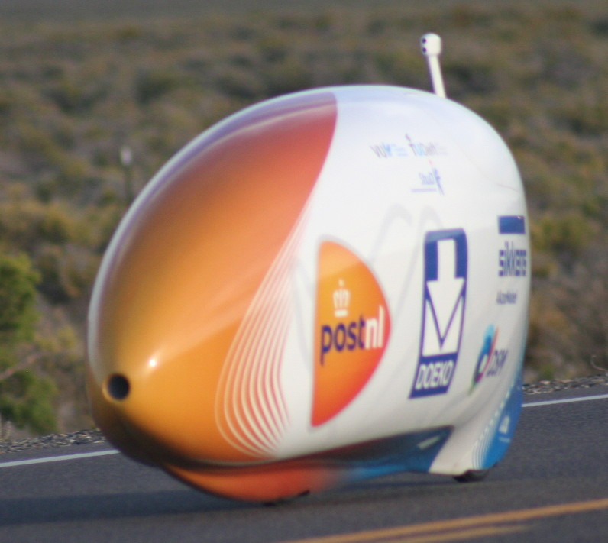
The new Delft/Amsterdam machine. The K drive is gone. 406 wheels give more design freedom. The amount I could see was a bit limited, but it is rear wheel drive. The front monocoque mounts the cranks and comes well back, allowing the entry hatch to be smaller. It has seat belts. A second subframe mounts the front wheel, for easy maint. The only other removable bit is the fairing around the rear wheel for easy access. A nice touch is that the camera pod mounts after the likely separation point and angles forward. They changed tyres for each run. It got the record!
Nitro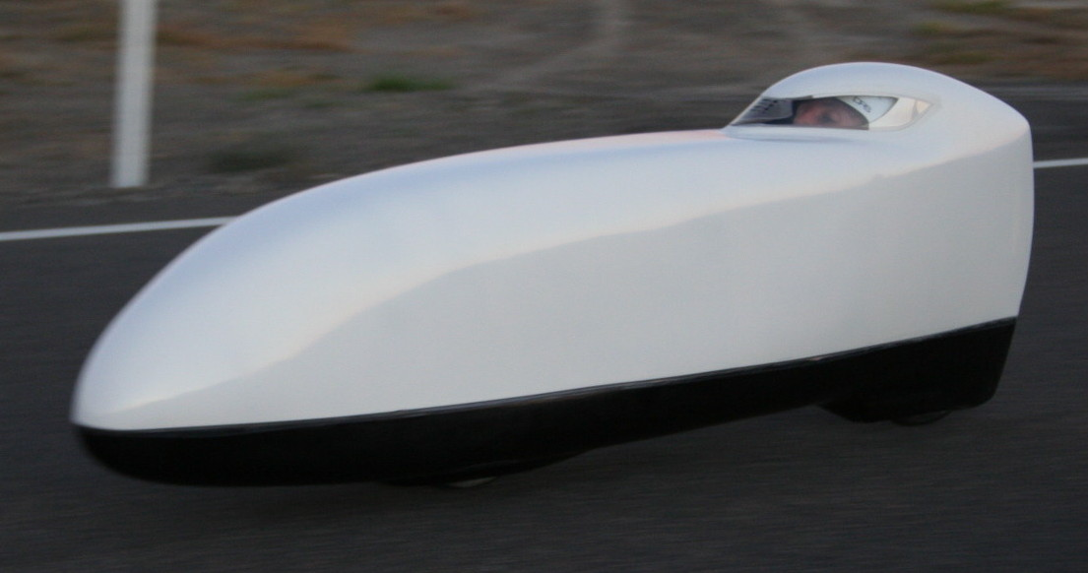
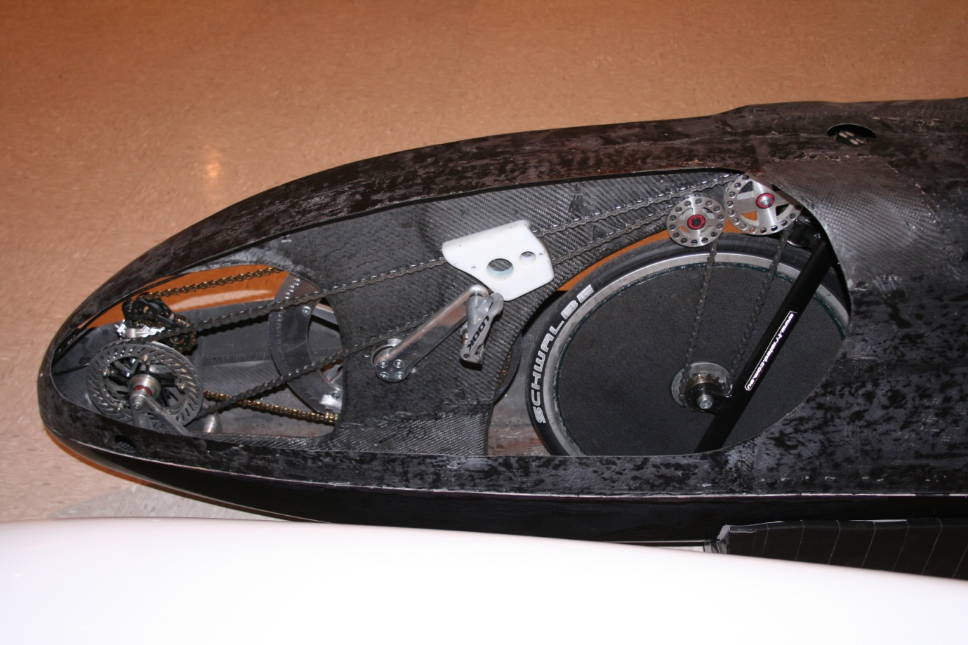
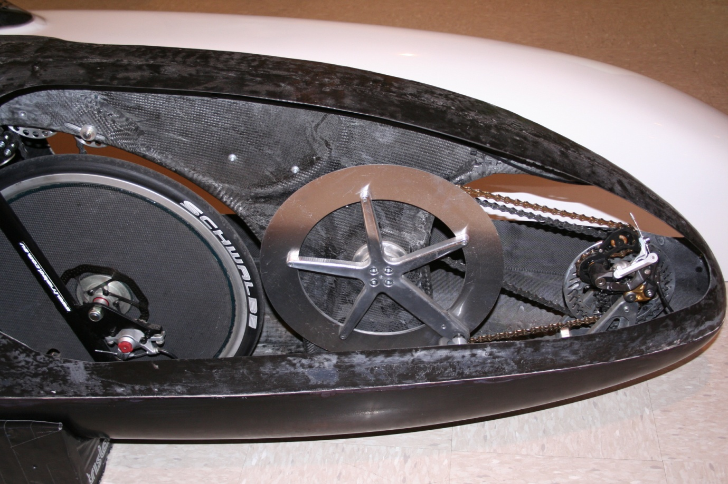

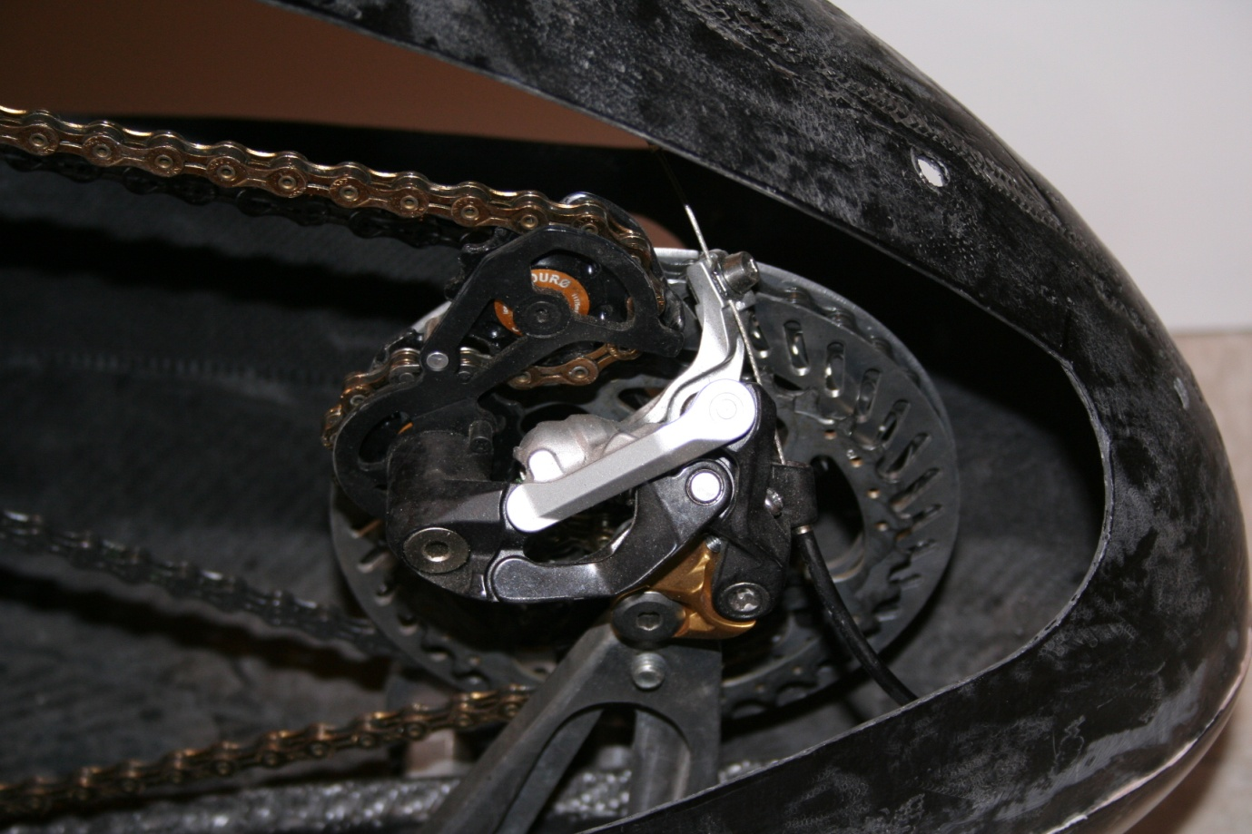
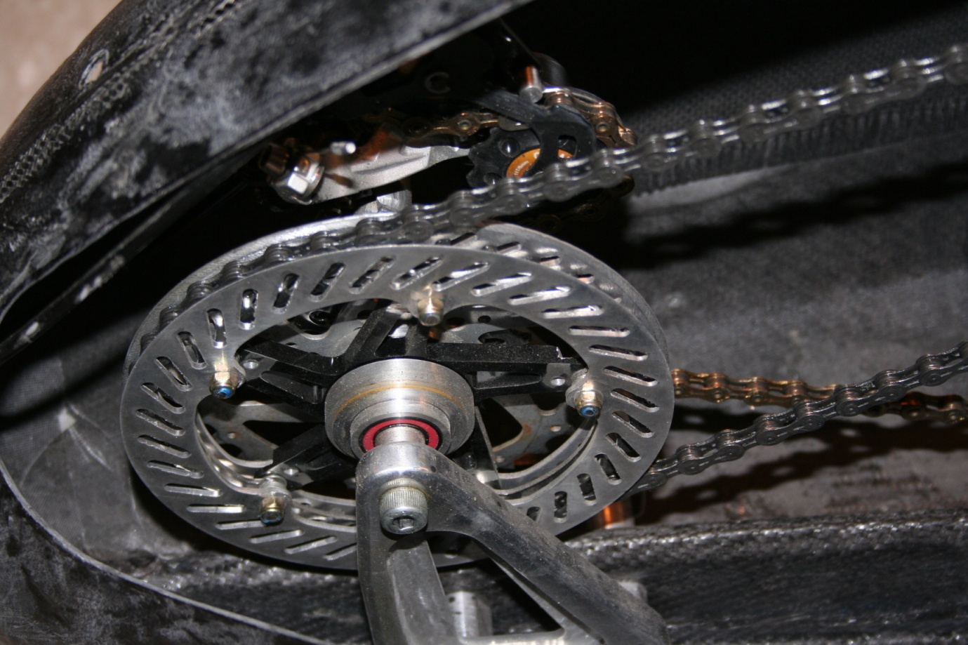
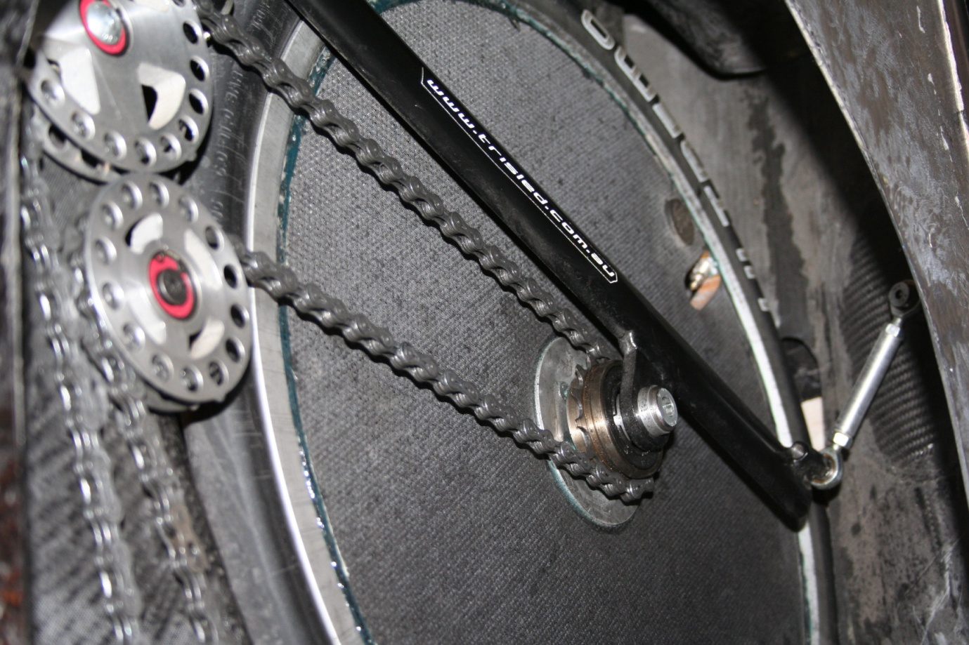
Slightly changed from last year. Nicer nose shape. Very neat transfer shaft in the nose and an internal structure like Altair. I think Ben did this first. Note links between forks and shell. Varna started this kind of thing. Controlling the wheel opening lets it be smaller.
Primal 2
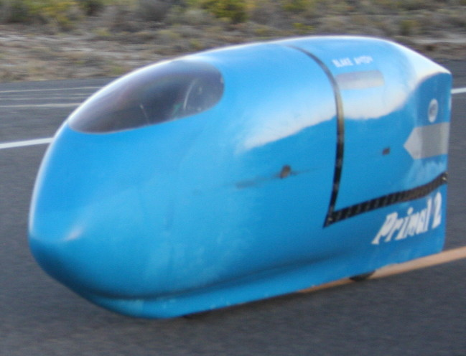
The same old bike. Steel bike with roll over cage, thin composite shell. Blake is a new rider and did well. Come on George! Time for something new.
Bowstring/Tativa 3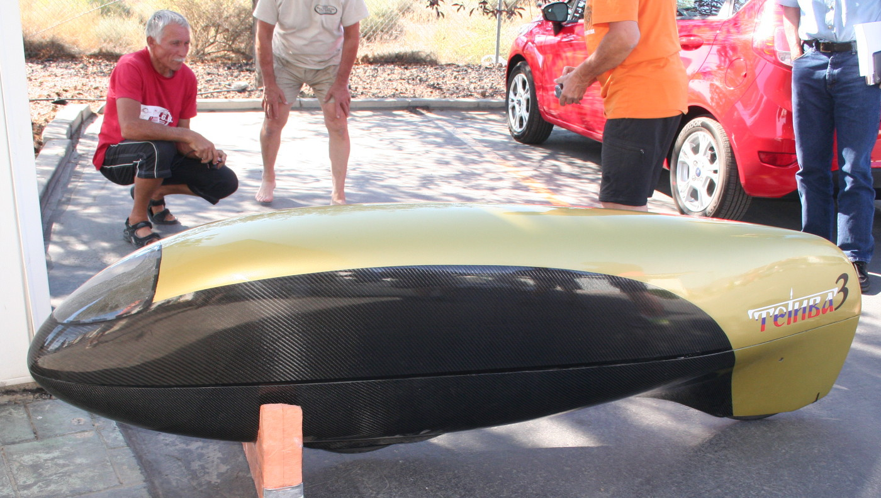
was a new version. Tiny and sleek. Sergey had a lot of launch problems. He says the bike is a bit too tight to steer. Benjamin, who designed it, has a vast history in Soviet/Russian HPVs. We have quite a few acquaintances from way back.
Cygnus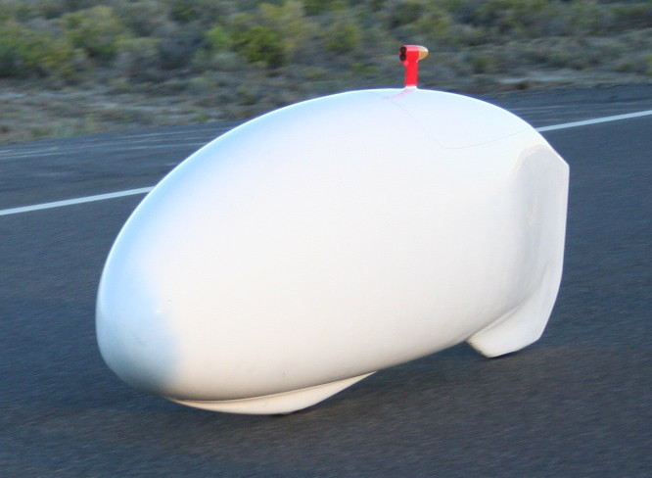
Has not changed a lot. Just the tops for the riders are a bit sleeker. Cygnus is one of the best bikes in the event. Sebastian can make 500 watts. Jan Marcel about 270. Do the numbers!
Big Nose Pete
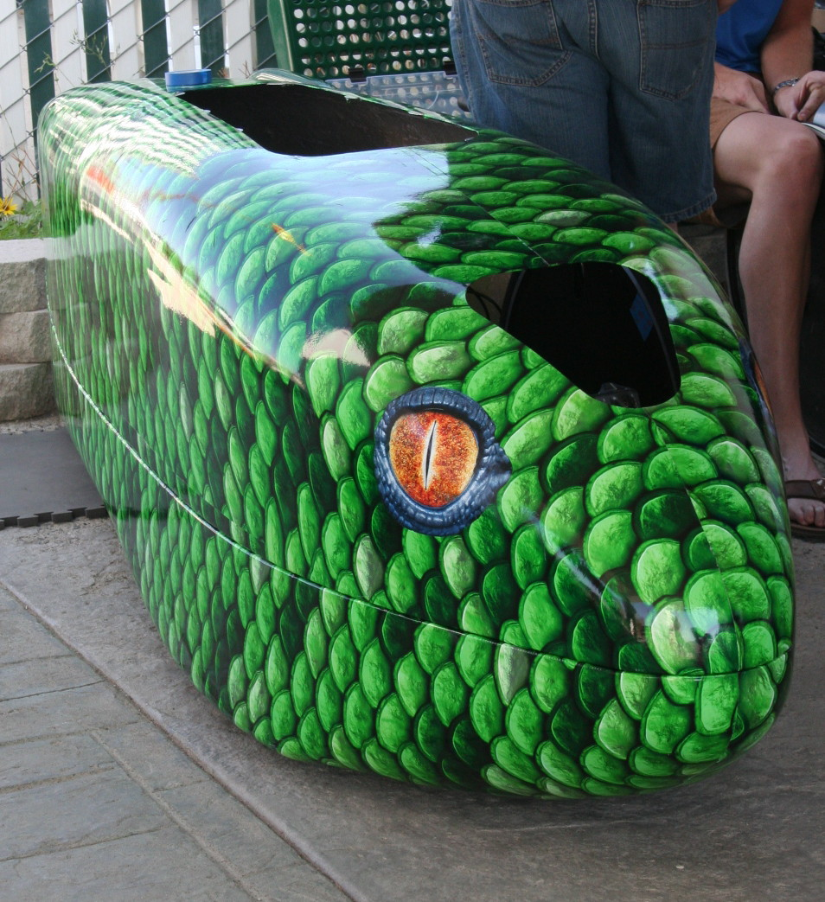 A tadpole trike. Steel frame. Great printed film job. Good rider and well sorted, but not a good shape. If it slithered off into the sagebrush we would never have found it.
Chuck Norus/Norush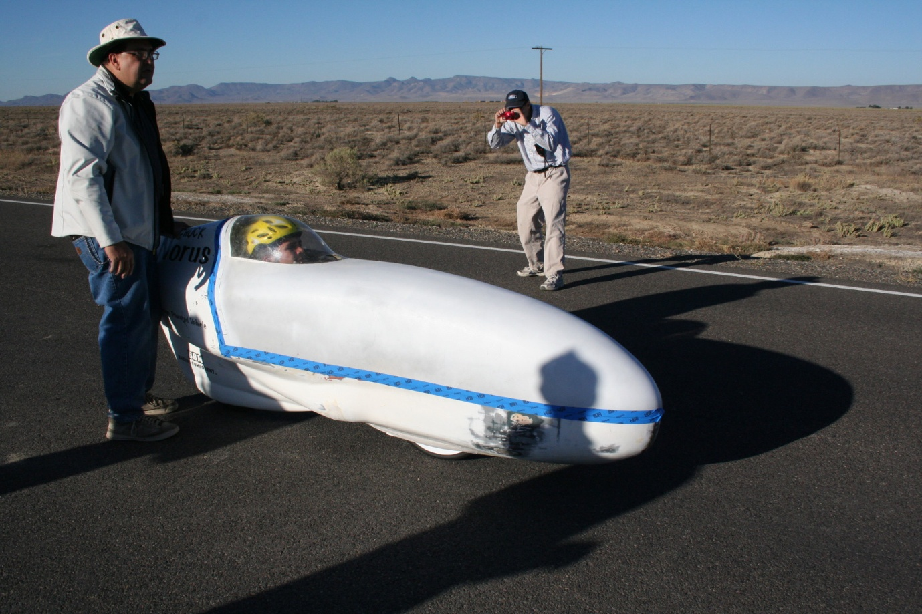
A road practical streamliner. Properly painted frame! Mike Mowatt owns it but has been nervous about riding it. This year the star rider was Florian Kowalik. He’s a junior and got quite close to the record, but he was misting up on his last run and lost it in the traps. Injury to bike only. Florian exceeded 55 mph. Mike was close to 60.
Glowworm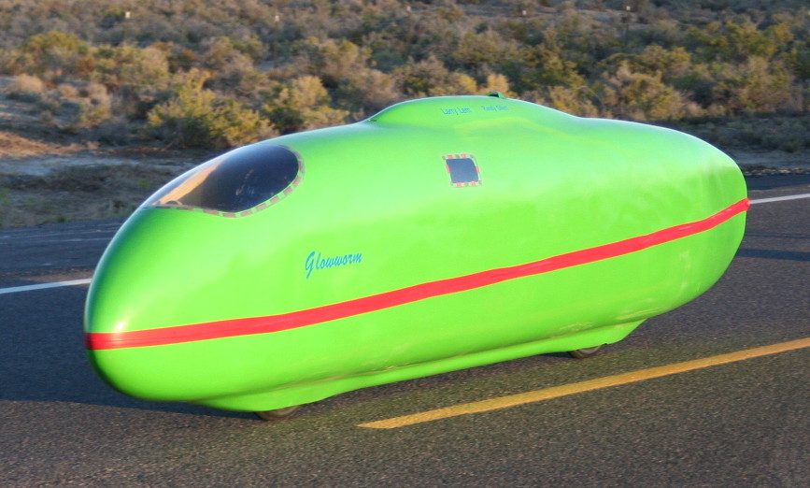This time Phil Plath was pilot and Randy Gillett stoker. A considerable power increase. It took a few runs for Phil to get used to piloting. Then they did a near record run, then trashed it quite well. They lost it on the bridge, after the traps. No idea how. There is a video which shows it right on the tail of Velox. The bike stove in the front, popped the top and spun, imbedding the back end in the boards along the bridge. Phil had some nasty road rash on his leg. Randy escaped with minor knocks. The bike didn’t. New one next time Larry?
Vortex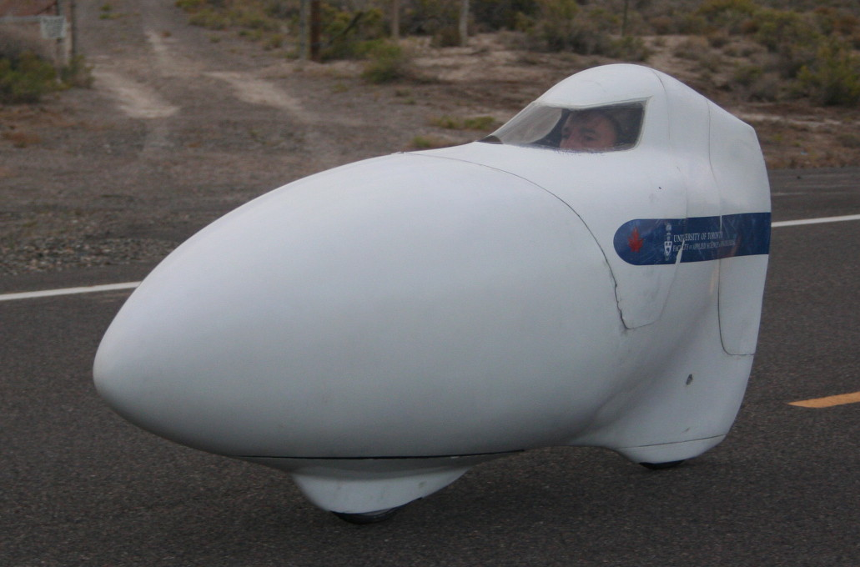
is the older Toronto bike. Neat and well sorted. The front wheel fairing pivots with the wheel. Went very well. Graeme had a ride in it at the end of the week and did a qualifying run. He didn’t feel he could apply full effort. This bike ran on Ultremos with cut and shut latex tubes.
Varna Tempest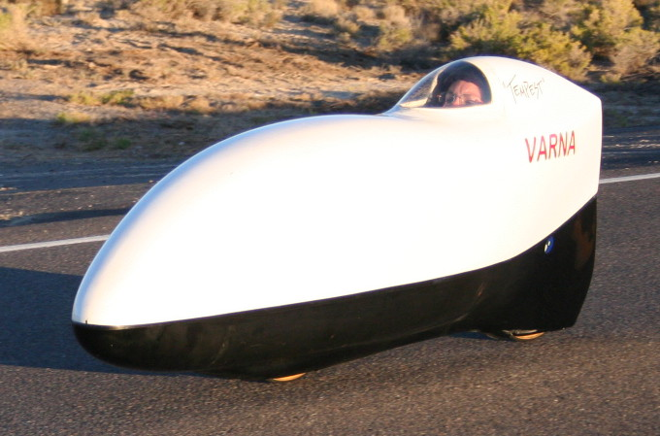

Nothing new from the Varnas. They brought the Battle Mountain as a backup. Barbara did 72 mph, which is fair, but the strange weather meant most riders did both night and morning. Barbara felt this was too much, but she had to in order to retain her run slot.

Svengali 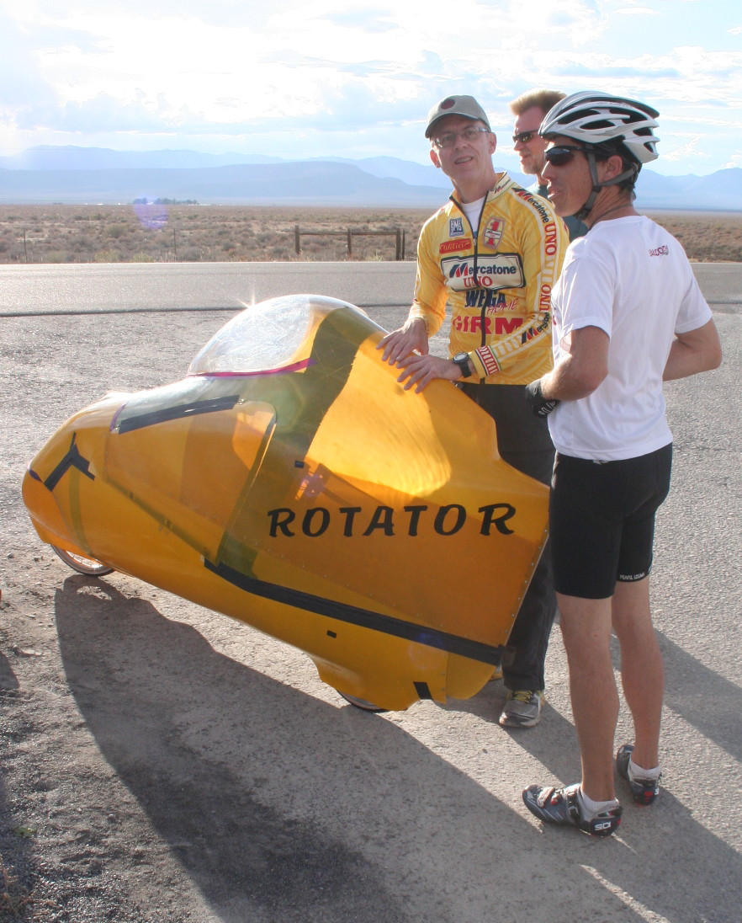
Sven (on the right) didn’t finish the new bike. It is called Grace. It looks like a small Varna. Svengali is a Delair Rotator Super 7, with some Goldrush in the top and rear fairing. The Rotator is Antique but quite clever. The frame includes lower seat frames all through which the fairing joins to. It is long wheelbase with remote steer. The front part of the fairing steers with the front wheel. It was nice to see, And Sven is a great guy. A professional circus performer and very good sport. He let slots go and helped on the course.
However, we can really do without having to run a retro class!
* ASME American Society of Mechanical Engineers. Competitors are colleges. Multi rider long races. It looks like the rules are trying to be set against the fast guys. Shame when they can go as well as Toronto. Their bikes can carry a load, turn tightly and probably commute.
Talking to Toronto we were joking about future camera systems. A projector onto the inside of the shell might work. Maybe one day a screen will be able to be sprayed on the inside!

